TOPIC: Types of Locators
Contents

1. Locators 1
1.1 Locate by ID 2
1.2 Locate by ClassName 3
1.3 Locate by Name 4
1.4 Locate by Tag Name 5
1.5 Locate by Link Text 6
1.6 Locate by Partial Link Text 7
1.7 Locate by CSS 8
2. XPath Locators 3
2.1 XPath Locator by ID 4
2.2 XPath Locator by Class Name 5
2.3 XPath Locator by Name 6
2.4 XPath Locator by Tag Name 7
2.5 XPath Locator by Text 8
2.6 XPath Locator by Contains 9
2.7 XPath Locator by Starts With 10
2.8 Best Practices for Writing XPath Expressions 11

After completing this manual, you will be able to:
- Understand the DOM and web elements
- Inspect elements using Developer Tools
- Identify suitable Selenium locators
- Write locators using:
  - ID
  - Name
  - Class Name
  - Tag Name
  - Link Text
  - CSS
  - XPath
- Test and debug locators in Developer Tools

What is a Locator?
A locator can be an ID, name, class name, CSS selector, or XPath expression. Using a locator, you can instruct Selenium to find a web element and perform an action on it, such as clicking a button, filling out a form, or selecting an option from a drop-down menu.
- ID Locator: It locates a web element based on its ID attribute. It is generally considered the fastest and most reliable, as ID attributes are supposed to be unique on a web page.

- ClassName Locator: It finds a web element based on its class attribute. Class Name is useful when the element has a suitable class that uniquely identifies the target element. If several elements share the class, additional refinement may be required.

- Name Locator: It helps in locating a web element based on its name attribute. This locator is helpful when interacting with form elements like text boxes, radio buttons, and checkboxes.

- Tag Name Locator: Based on its HTML tag name, elements are located. This locator is helpful when you must interact with all elements of a specific type, such as all links or all buttons.

- Link Text Locator: Based on the text of a hyperlink, a link text locator finds a web element in the DOM. It is helpful when interacting with a specific link on a web page.

- Partial Link Text Locator: Uses a partial match of the text of a hyperlink to find a web element in the DOM. This locator is helpful when interacting with a link with a changing or dynamic text value

- CSS Locator: The CSS locator is used to locate web elements based on their CSS selector. The CSS selector is a pattern that is used to select web elements based on their attributes, such as ID, class, and name.

- XPath Locator: It searches and navigates to the web element based on its position within the DOM tree or its attribute values. XPath locators are robust but can be slower and more brittle than other types of Locators in Selenium.

Which Locator Should I Use?
Situation | Preferred Locator
Unique id available | ID
Unique name available | Name
Unique class available | Class Name
Need to identify a hyperlink by visible text | Link Text
Need a flexible attribute-based locator | CSS
Element has no useful unique attribute | XPath
Need partial/dynamic matching | CSS / XPath
Need relationship-based identification | XPath

Locate by ID
The ID locator is one of the most commonly used Selenium locators. It is a unique identifier that is assigned to a web element on a web page.
You can use the inspect element option to locate an element directly from the webpage using [id=”<element>”]or use the By.id() method in Selenium to locate an element by its ID using the given syntax:
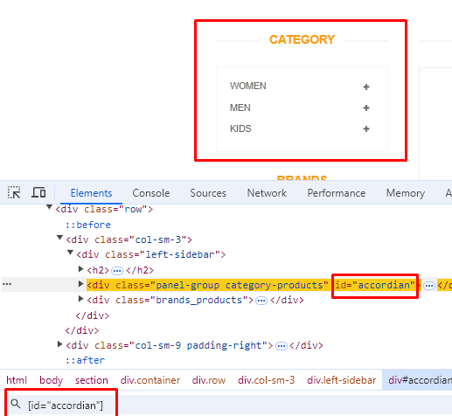
WebElement element = driver.findElement(By.id(“sale_image”))

Sr.No | URL | Element | Element Id
1 | https://www.automationexercise.com | Category frame | [id=”accordian”]
2 | https://www.automationexercise.com/products | Sale image | [id=“sale_image”]
3 | https://www.automationexercise.com/products | Submit search | [id="submit_search"]
4 | From students |  | [Id=
5 | From students |  | [Id=

Locate by ClassName

Locating elements by class name uses unique HTML class attributes. This approach is ideal when IDs are dynamic or absent, but class names are distinct. While generally faster and more efficient than XPath, class name location is less versatile than CSS selectors. It may not work for compound class names (with spaces) or elements with multiple classes. For multiple classes, CSS or XPath is more appropriate.
Syntax to use by.classname in Selenium:
WebElement element = driver.findElement(By.className(“test_case_list”));

Or locate using inspect element directly on webpage:
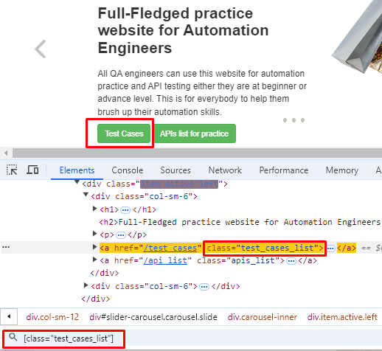
Sr.No | URL | Element | class attribute
1 | https://www.automationexercise.com | Test cases button | [class=” test_cases_list”]
2 | https://www.automationexercise.com | APIs List | [class="apis_list"]
3 | https://www.automationexercise.com/view_Cart | Empty cart message | [class="text-center"]
4 | From students |  | [class=
5 | From students |  | [class=

Locate by Name
Locating elements by name involves using an element's HTML 'name' attribute to identify it. This method is useful when other attributes like ID, class are not available. It requires unique 'name' attribute within the HTML document or it can be used where a list of elements is required having same name attribute.
Syntax to use by.name in Selenium:
WebElement element = driver.findElement(By.name (“name”));

Or locate using inspect element directly on webpage:
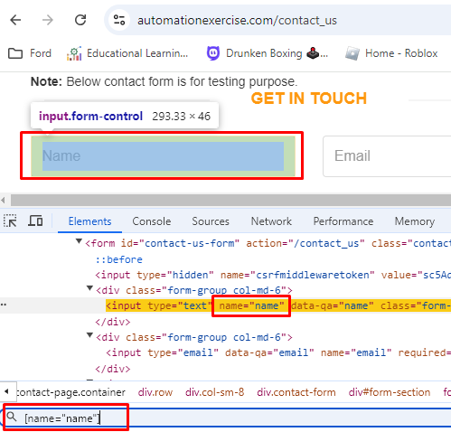

Sr.No | URL | Element | name attribute
1 | https://www.automationexercise.com/contact_us | Name input | [name="name"]
2 | https://www.automationexercise.com/contact_us | Email input | [name="email"]
3 | https://www.automationexercise.com/contact_us | Subject input | [name="subject"]
4 | From students |  | [name=
5 | From students |  | [name=

Locate by Tag Name
Locating elements by tag name is a method used to identify HTML elements based on their tag name, such as div, span, input, and others. However, it may return multiple elements if not specific enough, requiring additional refinement.
Common use cases include finding all paragraphs, images, or form input fields on a webpage. Syntax to use by.name in Selenium:
WebElement element = driver.findElement(By.tagName(“title”));

Example to get number of input fields
List<WebElement> inputFields = driver.findElements(By.tagName("input")); System.out.println("Input fields count: " + inputFields.size());

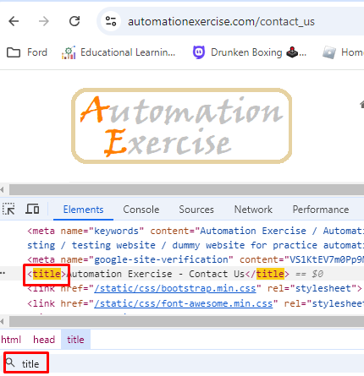
Or locate using inspect element directly on webpage:
Sr.No | URL | Element | Tag name
1 | https://www.automationexercise.com/contact_us | title | <title
2 | https://www.automationexercise.com/contact_us | all input fields | <input
3 | https://www.automationexercise.com/contact_us | All buttons | <button
4 | From students
5 | From students

Locate by Link Text
Locating elements by link text is a valuable strategy in Selenium for identifying hyperlinks on a webpage. This method involves searching for elements based on the visible text of the link, making it easy to use when the link text is unique. However, link text locators only work for <a> tags and may not be effective if the link text changes.
Syntax to use by.linkText in Selenium:
WebElement element = driver.findElement(By.linkText(“Contact us”));

Or locate using inspect element directly on webpage, in <a> tags text only.
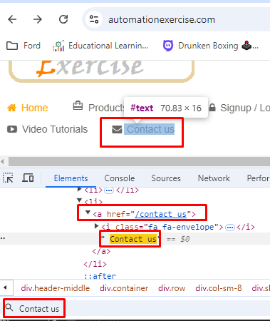
Sr.No | URL | Element | Element linktext
1 | https://www.automationexercise.com | Test cases | Test cases
2 | https://www.automationexercise.com | cart | Cart
3 | https://www.automationexercise.com | Contact us | Contact us
4 | From students
5 | From students

Locate by Partial Link Text
To locate an element by partial link text in Selenium using Java, utilize the By.partialLinkText method. This approach allows you to find a link element based on a partial match of its visible text. Partial Link Text can accidentally match the wrong link if the partial text is not unique.
Syntax to use by.linkText in Selenium:
WebElement element = driver.findElement(By.partialLinkText(“art”));

Or locate using inspect element directly on webpage, in <a> tags text only.
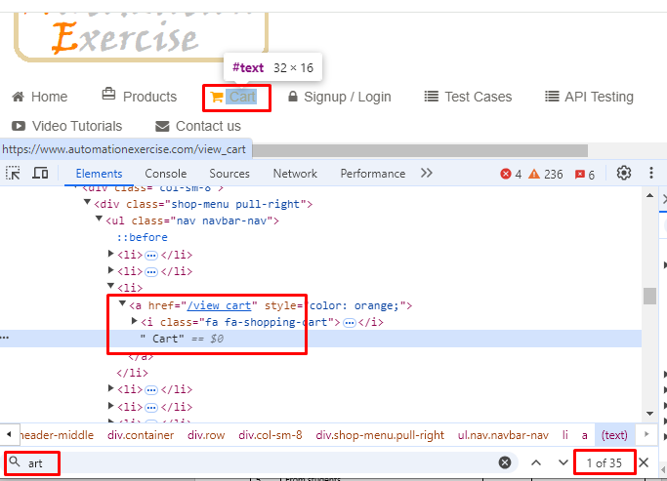

Sr.No | URL | Element | Partial link text
1 | https://www.automationexercise.com | products | pro
2 | https://www.automationexercise.com | cart | art
3 | https://www.automationexercise.com | Contact us | us
4 | From students
5 | From students

Locate by CSS
In CSS, an attribute (Type of Web Element) selector is a way to locate elements based on the presence or value of specific HTML attributes. This type of selector is useful when you want to target elements by attributes like id, class, name, placeholder, etc., without relying only on the tag name or class name.

Basic Syntax of CSS Attribute Selectors:
- Locate by Tagname: tagname input // Finds all <input> elements.
- Locate by id: #id: #username // Finds element with id="username"
- Locate by class: .classname .login-button// Finds element with class="login-button"
- Locate by Attribute: tagname[attribute='value']
  - [attribute='value']: Selects elements where the attribute is exactly equal to "value".
  - [attribute*='value']: Selects elements where the attribute contains "value" anywhere.
  - [attribute^='value']: Selects elements where the attribute starts with "value".
  - [attribute$='value']: Selects elements where the attribute ends with "value".
  - tagname[attribute1='value'][attribute2='value']: Locate by Multiple Attributes

Practice Example
Suppose you are working on this HTML:
<input type="text" id="email" name="userEmail" class="form-control">
You can use CSS selectors like:
#email // by ID
.form-control // by class
input[name='userEmail'] // by attribute
input[id='email'][type='text'] // multiple attributes

CSS Selector Cheat Sheet

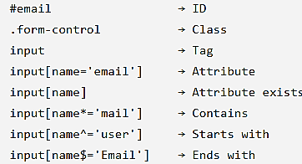

Examples from Automation Exercise Contact Us page
Let's look at a few examples using attribute selectors on this page.

1. Locate Element by Attribute Presence
- Example: Locate any input element with a name attribute.
List<WebElement> inputFields = driver.findElements(By.cssSelector("input[name]"));

2. Locate Element by Attribute Value
- Example: Locate the "Name" input field by its exact placeholder attribute value.
WebElement nameField = driver.findElement(By.cssSelector("input[placeholder='Name']"));

3. Locate Element by Partial Attribute Match (Contains)
- Example: Locate the "Email" input field by finding input elements whose placeholder contains "Email".
WebElement emailField = driver.findElement(By.cssSelector("input[placeholder*='Email']"));

4. Locate Element by Attribute Starts With
- Example: Locate any input field whose placeholder starts with "Sub" (e.g., for the "Subject" field).
WebElement subjectField = driver.findElement(By.cssSelector("input[placeholder^='Sub']"));

5. Locate Element by Attribute Ends With
- Example: Locate elements where placeholder ends with "Your Message".
WebElement messageField = driver.findElement(By.cssSelector("textarea[placeholder$=’ Message Here']"));

6. Locate Element by Multiple Attributes
- Example: Locate the "Submit" button using both type and id attributes.
WebElement submitButton = driver.findElement(By.cssSelector("input[type='submit'][name='submit']"));

XPath Locators
XPath stands for XML Path Language, and it's used to navigate through elements and attributes (Type of Locator) in an XML document. In Selenium, XPath is used to locate web elements in a web page, especially when other locators (id, name, class, etc.) are not available or insufficient. XPath is powerful and flexible, offering precision in finding elements.
XPath Syntax and Functions

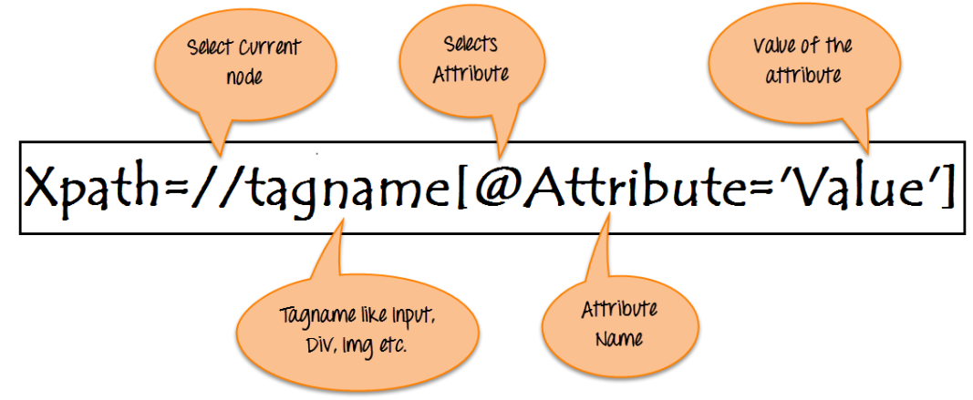
Basic Syntax: //tagname[@attribute='value']

Tagname = Type of Web Element (e.g. input, button, href, etc.)
Attribute = Type of Locator. (e.g. id, name, className)
Value = text of the type of the locator
Level 1 — Basic XPath
//input (Locates all <input> elements in the DOM based only on the tag name.)
Level 2 — Attribute
//input[@id='email'] (Locates an <input> element whose id attribute exactly matches email.)
Level 3 — Multiple attributes
//input[@type='text' and @name='email'] (Locates an <input> element that matches both the specified type and name attributes.)
Level 4 — Text
//button[text()='Login'] (Locates a <button> element whose visible text exactly matches Login.)

XPath Locator by ID
Description: Most straightforward and reliable if the ID is available and unique.
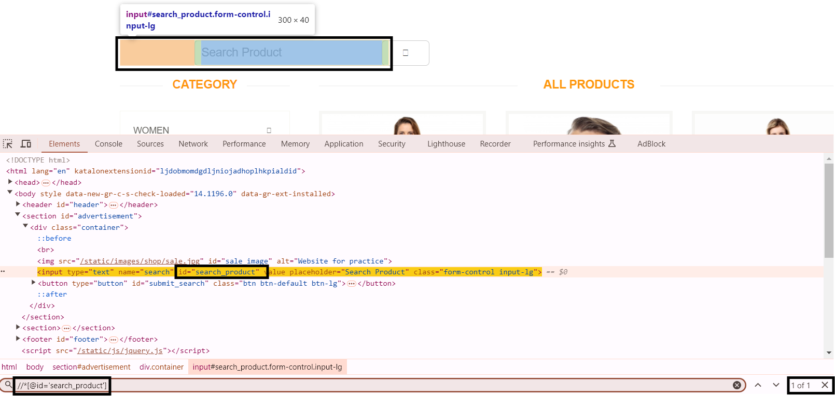
Example: (https://automationexercise.com/products) This locates the search bar on the products page.
// XPath locator by ID
WebElement productSearch = driver.findElement(By.xpath("//*[@id='search_product']"));

Other Examples: (https://automationexercise.com/products)
Sr. No | Description | Element | Element ID
 | This locates the search button next to the search bar. | Search Button | //*[@id='submit_search']
 | This locates the input field where users can enter their email address to subscribe. | Footer Subscribe Input Field. | //*[@id='susbscribe_email']
 | This locates the "Sale image” displayed at the top of the page. | Sale Image | //*[@id='sale_image']
 | From Students
 | From Students

XPath Locator by Class Name
Description: Locates an element by its class attribute. Useful when the class name is unique.
Example: (https://automationexercise.com/products) This locates the product list container with class features_items.
// XPath locator by Class Name
WebElement productContainer = driver.findElement(By.xpath("//*[@class='features_items']"));
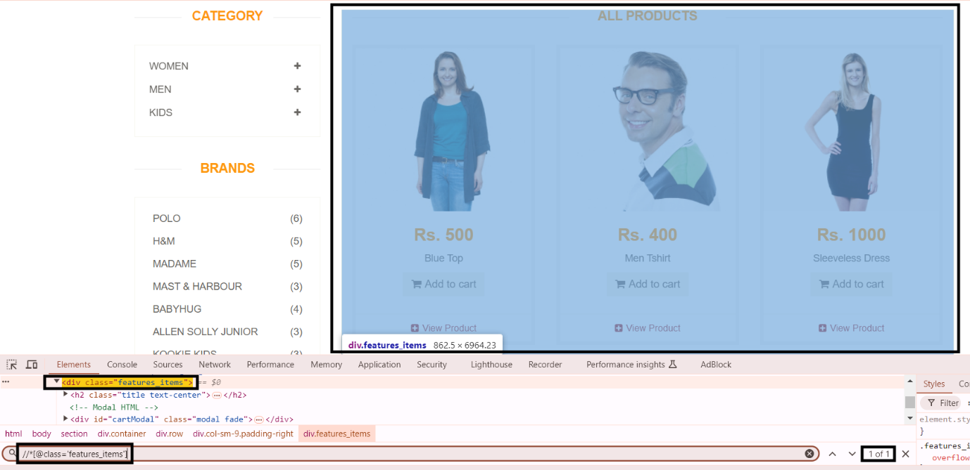

Other Examples: (https://automationexercise.com/products)
Sr. No | Description | Element | Element ID
 | This locates the image of the first product listed in the product section. | First Product’s Image | //*[@class='productinfo text-center']/img
 | This locates the entire product list section on the products page. | Product List Container | //*[@class='features_items']
 | This locates the <div> element with the class header-middle, which contains the top section of the page (logo and menu). | Header-middle Div Container | //*[@class='header-middle']
 | From Students
 | From Students

XPath Locator by Name
Description: Useful when locating form elements such as input fields, checkboxes, etc.
Example: (https://automationexercise.com/products) Locates the search input field by its name attribute.
// XPath locator by Name
WebElement searchBox = driver.findElement(By.xpath("//*[@name='search']"));
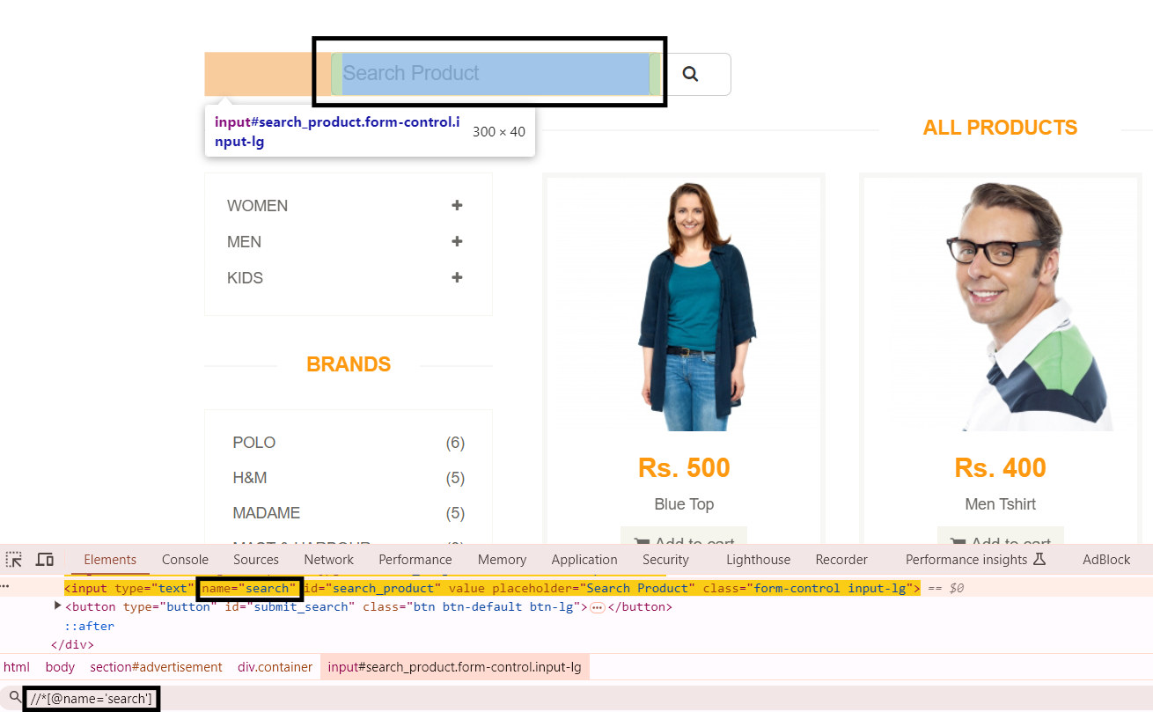

Other Examples: https://automationexercise.com/contact_us
Sr. No | Description | Element | Element ID
 | This XPath locator selects the input field for the user's name. | Name Input Field | //input[@name='name']
 | This XPath locator selects the input field for the user's email. | Email Input Field | //input[@name='email']
 | This XPath locator selects the input field for the subject of the message. | Subject Input Field | //input[@name='subject']
 | From Students
 | From Students

XPath Locator by Tag Name
Description: Locates elements using their HTML tag names. Usually, this is combined with other attributes or hierarchical elements.
Example: (https://automationexercise.com/products) This finds the first button element on the page, which can be refined for specific buttons.
// XPath locator by Tag Name
WebElement addToCartButton = driver.findElement(By.xpath("//button"));
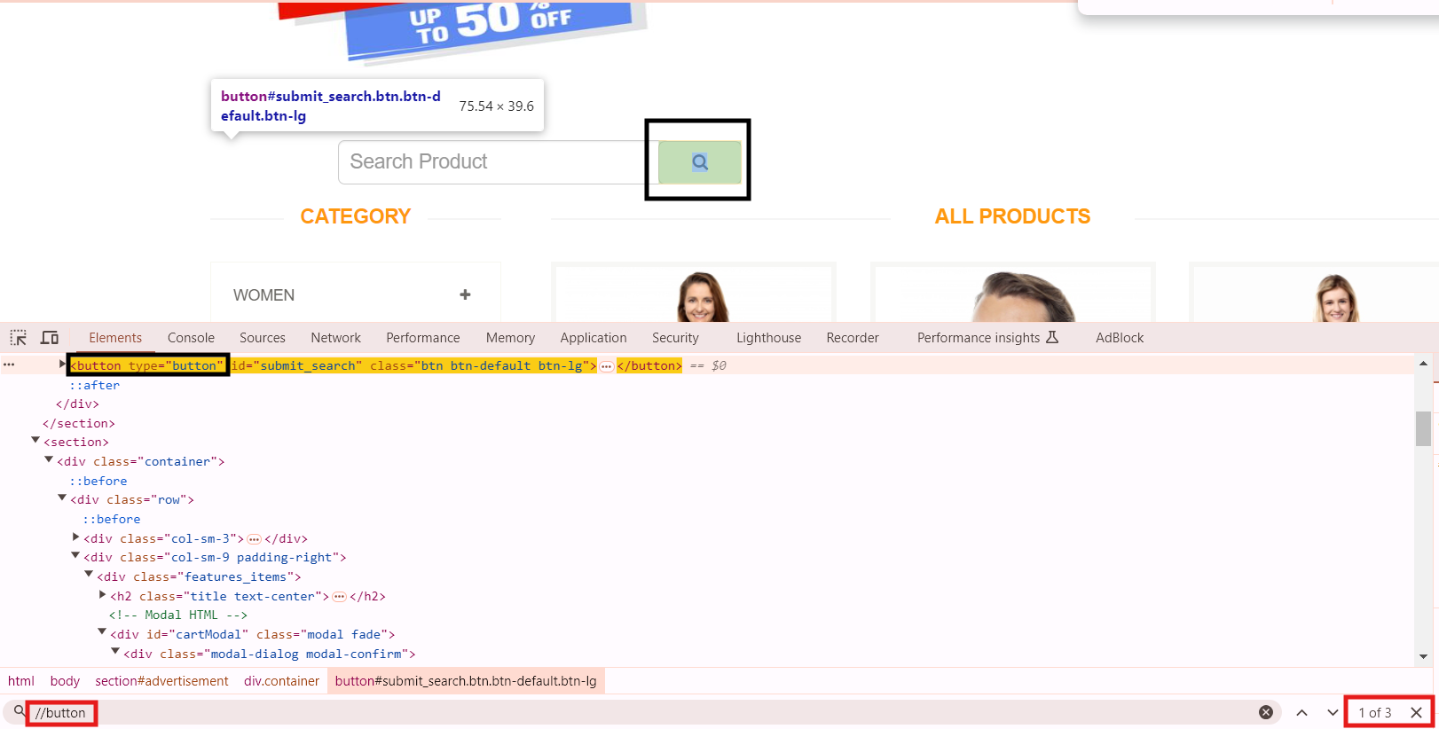
Other Examples: (https://automationexercise.com/products)
Sr. No | Description | Element | Element ID
 | This example uses the tag name h4 to locate all product titles on the products page. Each product title is wrapped in an h4 tag. | All Product Titles | //h4
 | This example uses the tag name img to locate all product images on the page. Each product image is represented by an img tag. | All Product Images | //img
 | This example uses the h2 tag to locate the heading that indicates the section for all products. | "All Products" Heading | //h2[@class='title text-center']
 | From Students
 | From Students

XPath Locator by Text
Description: Locates an element by its visible text. Useful for clickable links or button.
Example: (https://automationexercise.com/products) Locates the "Add to cart" button by the exact visible text.
// XPath locator by Text
WebElement addToCartText = driver.findElement(By.xpath("//*[text()='Add to cart']"));
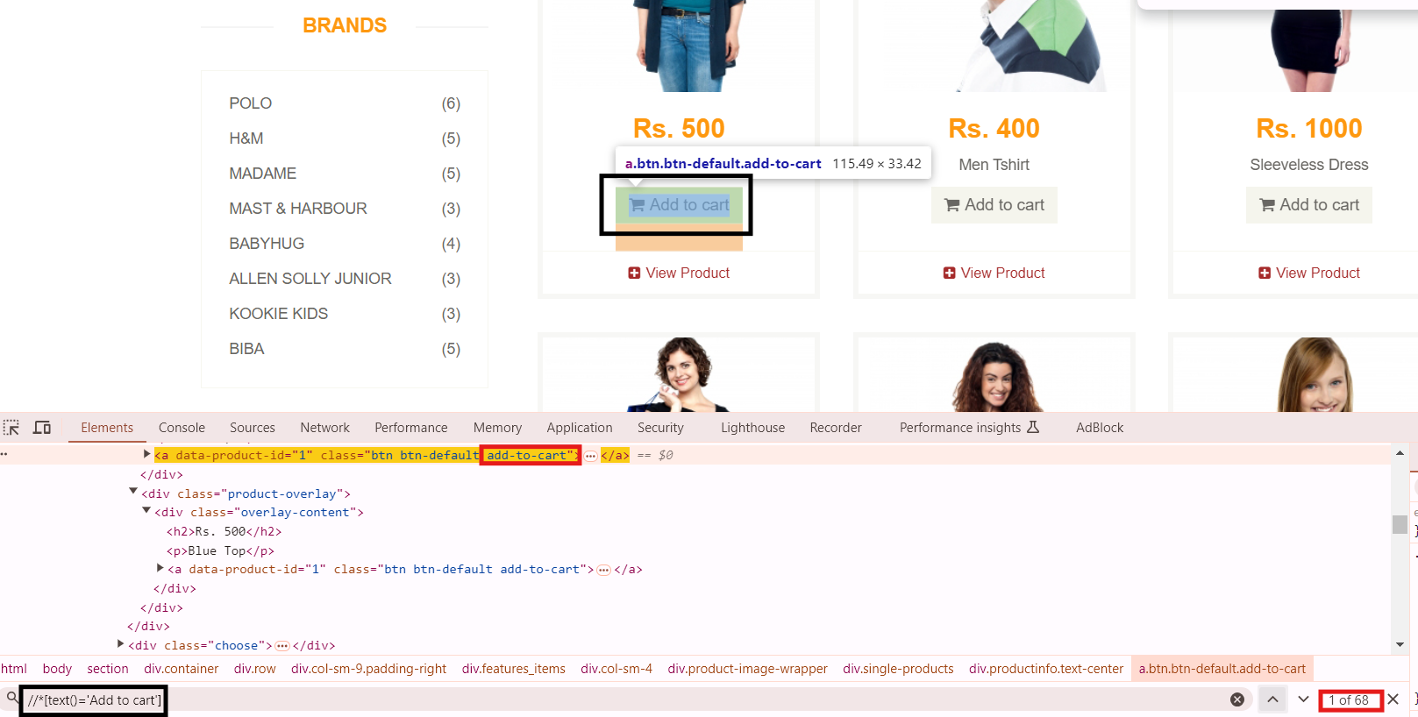

Other Examples: (https://automationexercise.com/products)
Sr. No | Description | Element | Element ID
 | This XPath locates the heading with the exact name "Brands." It targets the <h2> element containing the specified text. | Locate a heading by Exact Text | //h2[text()='Brands']
 | This XPath locates a link that contains the text "View Product." It is useful for navigating to a product detail page. | Locate a Link by Text | //a[text()='View Product']
 | This XPath finds all button labeled "Add to cart." | Locate a Button by Text | //a[text()='Add to cart']
 | From Students
 | From Students

XPath Locator by Contains
Description: Finds elements that contain a specific value or partial text within an attribute.
Example: (https://automationexercise.com/products) This locates elements with text that contains "View Product" for the product details button.
// XPath locator by Contains
WebElement viewProduct = driver.findElement(By.xpath("//*[contains(text(), 'View Product')]"));
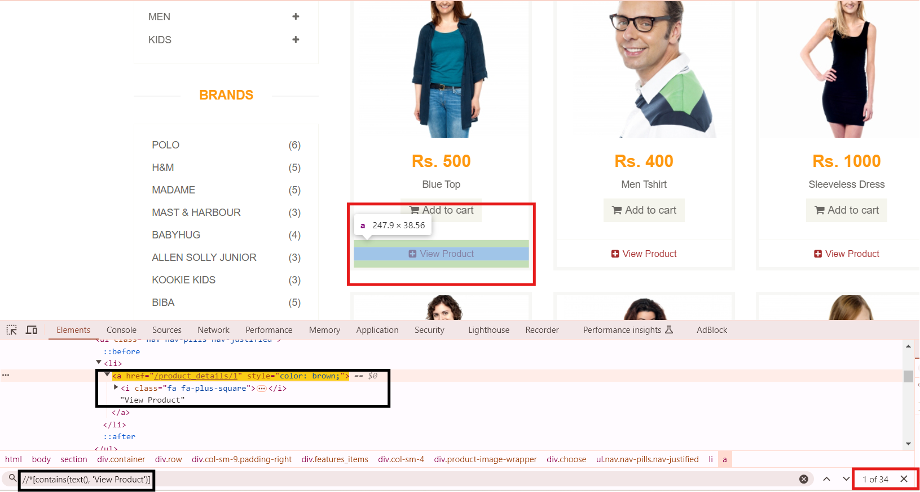
Other Examples: (https://automationexercise.com/contact_us)
Sr. No | Description | Element | Element ID
 | This XPath selects the "Name" input field using a partial match for the placeholder attribute, making it flexible for fields with dynamic or partial text in their placeholders. | Locate a Text Input Field by Partial Placeholder Attribute | //input[contains(@placeholder, 'Name')]
 | This XPath locates the heading of the contact form using a partial match for the visible text, making it suitable for headings with additional dynamic content. | Locate the Contact Form Heading by Partial Text | //h2[contains(text(), 'Contact')]
 | This XPath selects a link by partially matching the href attribute. It’s useful for links where the URL structure is dynamic but contains consistent segments. | Locate a Link by Partial Href Attribute | //a[contains(@href, 'contact_us')]
 | From Students
 | From Students

XPath Locator by Starts With
Description: Locates elements where an attribute starts with a specific string.
Example: (https://automationexercise.com/products) This locates the search input field with an ID starting with "search".
// XPath locator by Starts With
WebElement searchField = driver.findElement(By.xpath("//*[starts-with(@id, 'search')]"));
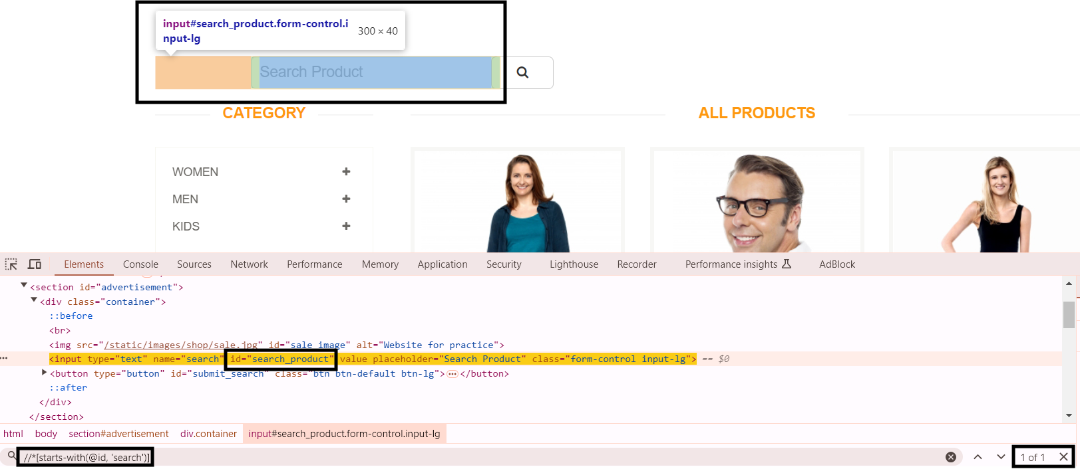
Other Examples: (https://automationexercise.com/contact_us)
Sr. No | Description | Element | Element ID
 | This XPath locates the main heading "Get in Touch" by using the starts-with() function to match the text that starts with "Get." It's useful when there is a consistent prefix but the rest of the text might change. | Locate the "Get in Touch" Heading by Start With | //h2[starts-with(text(),'Get')]
 | This example locates an input field by finding elements whose "name" attribute starts with "name". It helps in targeting multiple input fields that have similar naming conventions. | Locate an Input Field by Attribute Starting With | //input[starts-with(@name,'name')]
 | This XPath finds the submit button by targeting an attribute that starts with "subm." It's a useful approach when there are multiple buttons but you want to select the one with a common starting value in its attribute. | Locate the Submit Button by Starting Attribute Value | //button[starts-with(@type,'subm')]
 | From Students
 | From Students

